Assuming the following fixed parameters,

Nbar = 1.0

Nstar = 0.1432394487827058

tau_eq = 1 microsecond

sigma0 = 0.2

when the “baseline” scenario is perturbed a little to the following:

L = 30 micrometer

D = 0.000365 micrometer ** 2 / microsecond

nu_kin = 105 micrometer / second

nu_kin_mlyperus = 0.26992287917737784 / microsecond

sigmaI_corner = 0.22 dimensionless

c_r_percent = 1.068 dimensionless

nx (crystal) = 2401

Spacing of points on the ice surface = 0.02499999999999858 micrometer

we get instability:

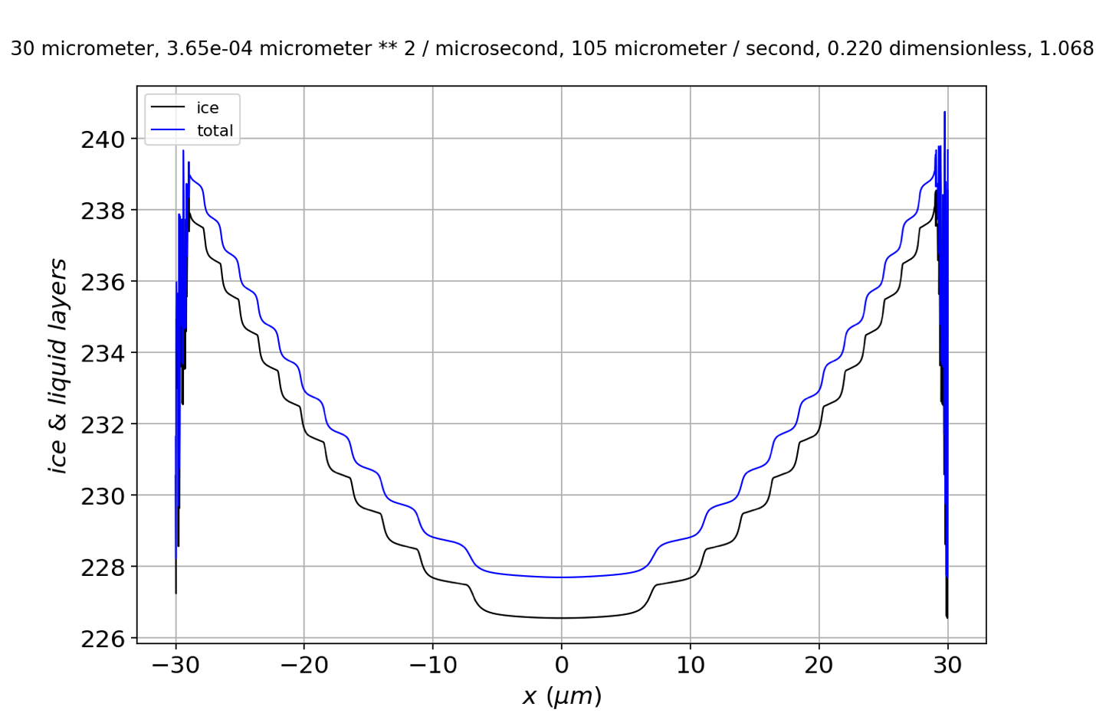

If we expand in the corner, it’s clear that instabilities have crept in, by this time, from the edge at to .

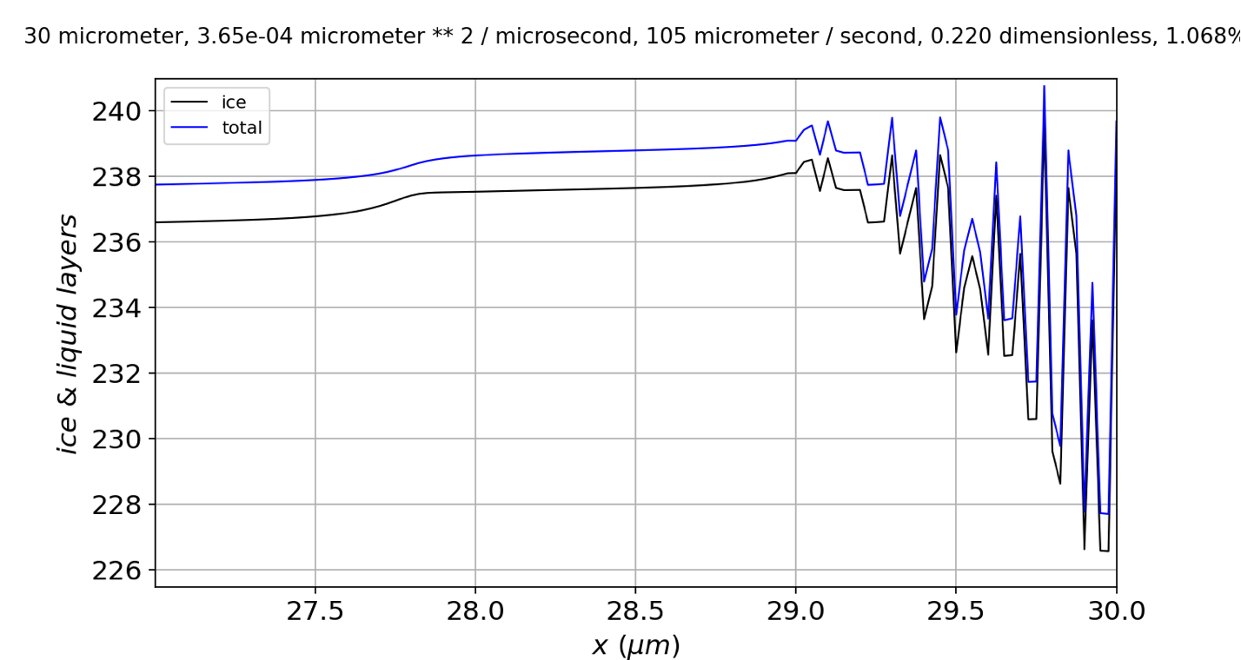

If we examine the alone,

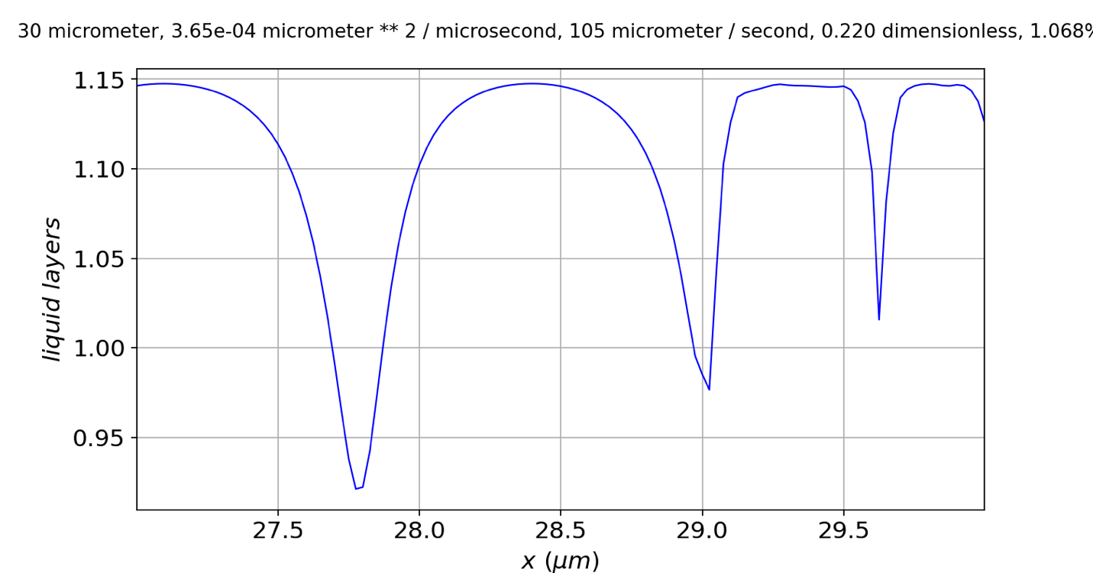

we see that the instability seems to originate on a *step*, rather than at a *riser* (solid arrow). The fact that tops out at risers generally (dashed arrows) with a value close to is significant, because the parameterization means that when is at its maximum value (), . That means, at that time step, deposition from the vapor phase has slightly exceeded the ability of the quasiliquid to **freeze** or **diffuse away**.

The latter point can be confirmed by setting the diffusion coefficient to a smaller value: if we lower it to (from the baseline ), **the** **instability goes away**.

If this thinking is correct, then we can predict that instability is caused by:

* Low
* High
* Low